I have a few comments, and will go through more detail with the team later, please find below:

- Canal Fanafo, there is a dash (-) when first read in area council structure, and there is no dash in dataset. Means that Canal Fanafo is dropping from Sanma, and then being re-attached at end under Tafea

Data Quality Fixes Applied to Baseline Data
We identified and corrected two types of data consistency issues in the input files:

1. Ordering Reference Correction
The Area Council "Canal Fanafo" was spelled "Canal - Fanafo" (with a dash) in the report's geographic ordering reference, but appears without a dash in the actual data files. This mismatch caused Canal Fanafo to be sorted incorrectly — appearing at the end of the report under Tafea Province instead of within Sanma Province where it belongs.
We have updated the ordering reference to match the data spelling.

2. Capitalization Standardization
Seven Area Council names had inconsistent capitalization in the baseline data file, which could cause records to be treated as separate locations or dropped from aggregations:
Original (in data) | Corrected
Central malekula | Central Malekula
Central pentecost 2 | Central Pentecost 2
East santo | East Santo
luganville | Luganville
North West malekula | North West Malekula
pentecost | Pentecost
West gaua | West Gaua

We have added automatic standardisation when loading the baseline data.

Recommendation
These corrections should ideally be applied to the source data file to ensure consistency across all systems using this data.

Everything is correct now.

- 78 entries in the ordering reference: National + 6 provinces + 71 Area Councils
- 71 Area Councils validated (excluding National and provinces)
- All 71 Area Councils have consistent naming

The data is now clean:
- Case inconsistencies are standardized
- Island-level aggregates (Ambae, Malekula, etc.) are filtered out
- All 71 Area Councils have consistent naming that matches region_order

- Could we also establish some quality checks in terms of reading in data & outputs, these don't have to be completely automated- for instance a random subset of outputs that we can then manually quality check, or whatever you have in mind

Quality Control System Added to the Report

What we added:
We implemented an automated quality control (QC) system that runs each time the report is generated. It consists of two components:
- Input Data Validation (runs at the start, before calculations)
- Output Validation (runs at the end, after all tables are generated)

Why we added it:
During development, we discovered several data consistency issues that could silently affect results:
- Council names with inconsistent capitalization (e.g., "luganville" vs "Luganville")
- Council names with slightly different spelling between files
- Missing baseline data for some sectors in certain councils
Without automated checks, these issues would go undetected and could cause councils to be dropped from aggregations or sorted incorrectly.

What it checks:
Check | Purpose
Area Councils recognized | Detects new or misspelled council names
No capitalization issues | Catches case inconsistencies that cause failed joins
Config-baseline alignment | Ensures all cyclone-affected councils have baseline data
Required baseline completeness | Verifies core sectors (Education, Energy, Shelter, etc.) have data
Output file validation | Confirms no negative values or calculation errors in final outputs
Outputs produced:
File | Purpose
QC_baseline_coverage.csv | Shows which baselines exist for each council
QC_manual_review_sample.csv | Random sample of 5 councils with key metrics for spot-checking against report tables

How to use it:
If all checks show "✓ Pass" — the report is ready
If any check shows "⚠️ Issues" — investigate before distributing the report
Periodically open QC_manual_review_sample.csv and verify the numbers match the corresponding tables in the report

- The functions that enable you to calculate components 2/3/4 from each sector for example estimate damage number of schools and children affected, wasn't sure how you input multiple parameters and then feeds into automation process, would be great if you could demonstrate this.

How the Damage Calculation Functions Work

The report uses helper functions that take multiple parameters and return the appropriate multiplier or value. Here's a walkthrough using Education as an example:

Step 1: The Damage Multiplier Function

get_damage_multiplier <- function(cyclone_category, education_level, measure_type, area_council) {
intensity_col <- paste0("Intensity ", cyclone_category) # e.g., "Intensity 3"

multiplier <- baseline_factors %>%
filter(
Cluster == "Education",
Attribute == education_level, # e.g., "primary"
grepl(measure_type, Indicator, ignore.case = TRUE), # e.g., "schools"
`Area Council` == area_council # e.g., "West Tanna"
)

result <- multiplier[[intensity_col]][1] # Get the value from the intensity column
return(ifelse(is.na(result), 0, result))
}

Step 2: How it's called in the calculation

For each council row, the function is called with that council's specific parameters:

damage_estimates <- education_with_config %>%
filter(!is.na(Intensity)) %>%
rowwise() %>%
mutate(
# For each row, calls the function with THAT row's values
primary_schools_damaged = round(
primary_schools * get_damage_multiplier(Intensity, "primary", "schools", Region) )
# Intensity = 3 (from config)
# "primary" = education level
# "schools" = what we're measuring
# Region = "West Tanna" (from current row)
)

Step 3: Concrete example

For West Tanna with Intensity 3

primary_schools (baseline) = 44
Intensity (from config) = 3
Damage multiplier (from lookup) = 0.25 (25%)

Result: primary_schools_damaged 44 × 0.25 = 11 schools

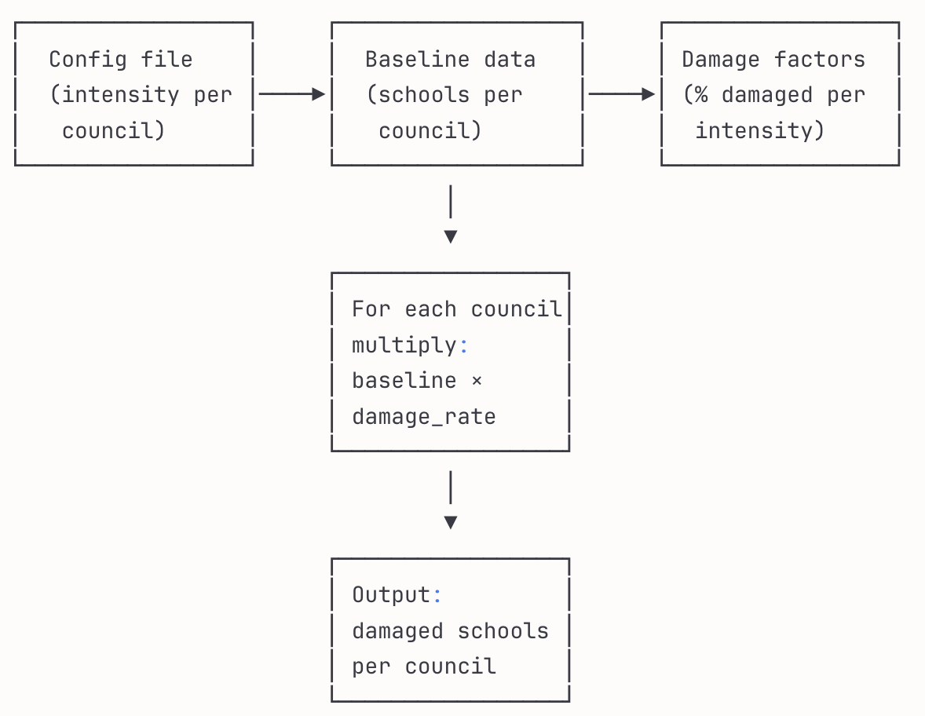

- Again links to a demo, if we want to change table format not area boundaries but column variables, multiplying factors, and challenges associated- matching variables etc would be great to touch base on these too

Modifying the report: What can be changed and where
The report is designed to read configuration from external CSV files, making many changes possible without editing code. However, some changes require code modifications.

1. Changes that DON'T require code edits (just update CSV files):
Change | File to modify
Add/remove councils from cyclone scenario | Ex_hazard_areas.csv
Change cyclone intensity for a council | Ex_hazard_areas.csv
Update baseline values (e.g., new school built) | 1c_input_baseline.csv
Change damage percentages | 2a Input- Damage Multiplier.csv
Change resource quantities per unit | 3aii Input- Resources Sent.csv
Change unit costs | 4a Input- Finance Estimates.csv

2. Changes that DO require code edits:
Change | What to modify | Complexity
Add a new sector (e.g., Tourism) | Add new section in report | High
Add new columns to existing tables | Update select(), mutate(), colDef() | Medium
Rename existing columns | Update column references throughout section | Medium
Change aggregation logic | Modify compute_council_aggregates() | Medium
Add new resource type | Update resources calculation + table display | Medium

3. Key matching variables (must be consistent across files):
These column values must match exactly between files, or joins will fail:

Variable | Used in | Must match with
Area Council | All files | Exact spelling and capitalization
Cluster | Multipliers, Resources, Finance | Sector names in baseline (e.g., "Education")
Indicator | All config files | e.g., "Number Schools", "Health Facility"
Attribute | All config files | e.g., "primary", "ecce", "hospital"
Intensity 2, Intensity 3, Intensity 4 | Damage multipliers | Column names must be exact

4. Common challenges and solutions:
Challenge | Symptom | Solution
Column name mismatch | NAs or 0s in output | Check spelling in CSV headers
New council added | Council missing from tables | Add to region_order and council_province_lookup.csv
New attribute added | Values not appearing | Add to case_when() or pivot_wider() logic
Spaces in names | Join failures | Use backticks: `Area Council`

- In terms of calculating the resources needed for response, I saw you had number days= 14, and then this became a parameter later in function, if there is something else we want to add, could you please show us how this could be done also

Configurable Parameters in the Report

Current example: days_of_support

In the Education resources calculation, you'll see:

# Configuration parameters
days_of_support <- 14 # Number of days to provide resources

# Used in calculations
ecce_water = ceiling(ecce_students * damage_multiplier *
get_resource_multiplier("Water") * days_of_support),
ecce_tin_fish = round(ecce_students * damage_multiplier *
get_resource_multiplier("Tin Fish") * days_of_support, 0),

This means: water and food are calculated as per student per day × number of days.

How to add new configurable parameters:

Step 1: Define the parameter at the top of the relevant section:

# Configuration parameters
days_of_support <- 14 # Days of emergency supplies
household_size <- 4.5 # Average people per household
buffer_percentage <- 1.10 # 10% extra for contingency
distribution_losses <- 0.05 # 5% loss during distribution

Step 2: Use it in calculations:

mutate(
# Water needed = affected people × litres per person × days × buffer
total_water = ceiling(affected_population *
get_resource_multiplier("Water") *
days_of_support *
buffer_percentage),

# Tents needed = damaged households, adjusted for losses
tents_needed = ceiling(damaged_households *
get_resource_multiplier("Tent") /
(1 - distribution_losses))
)

Practical examples of parameters you might add:
- days_of_support: Duration of emergency response → used for food, water quantities
- household_size: Average people per household → used to convert households to people for per-capita calculations
- buffer_stock: Safety margin for supplies → multiplier for final resource quantities
- reconstruction_months: Recovery timeline → used for financial planning
- inflation_rate: Adjust historical costs → update unit costs to current values
- exchange_rate: Convert VT to USD → for international reporting

Option: Move parameters to a config file
For easier adjustment without editing code, you could create a parameters.csv:

Parameter,Value,Description
days_of_support,14,Days of emergency supplies
household_size,4.5,Average people per household
buffer_percentage,1.10,Safety margin multiplier

Then load it in the report:
params <- read.csv(here::here("Data", "parameters.csv"))

days_of_support <- params %>% filter(Parameter == "days_of_support") %>% pull(Value)
household_size <- params %>% filter(Parameter == "household_size") %>% pull(Value)

This allows changing parameters without opening the report code.

- I calculated some of the numbers from the excel against the output in the report, their are quite a few small differences, I am assuming due to rounding, however I thought there were quite large ones in some of the sections including Energy

Explaining the Differences

Small differences between Excel and the report are expected due to:
- Rounding at different stages: The report rounds at the council level before summing to province/national totals. If Excel rounds at the end, totals will differ slightly.
- Decimal precision: R maintains full precision during calculations, while Excel may display/use rounded values in intermediate steps.
- Different rounding rules: R's round() uses "banker's rounding" (0.5 rounds to nearest even number), while Excel always rounds 0.5 up.

For larger differences in Energy specifically, possible causes include:
- Councils with missing infrastructure data (we fixed one issue where 5 councils had NA values)
- Join mismatches between household and infrastructure tables
- Different assumptions about which councils are affected

Suggestion: Add a validation export
We can add a chunk that exports intermediate calculation values (before rounding and aggregation) to CSV files. This would allow you to:
- Compare step-by-step with their Excel workbook
- Identify exactly where differences originate
- Verify the multipliers being applied

Example output files:
- Validation_Energy_raw_calculations.csv
- Validation_Education_raw_calculations.csv
- etc.

Would you like us to add these validation exports to the report?

- Do you have time to add any more visuals to the report, or will the output be these tables, I am not sure what your initial thoughts were but would be great to hear more

We have now added an example of a visualisation that could be added throughout the report to complement the tables (in Section 14 of the report). It is an interactive map produced with Leaflet. The example illustrates Section 10 - Shelter, Table 10.2 - Estimated Hazard Damage, with the total private households damaged mapped on councils affected by the cyclone using a colour gradient. When hovering over each council, detailed data from the rest of the table is displayed, including Main Roof Materials Damaged (Concrete, Metal, Wood) and Main Wall Materials Damaged (Concrete, Metal, Wood). Councils shown in grey have no damage data available.

- Some tables you did not round such as Emergency telecommunications, assuming as would have rounded to zero- more for us, we have to think through how to report this

Current approach in the report:

Different sections handle this differently:
- Education: Rounds damage estimates to whole numbers
- Health: Rounds after aggregation
- Emergency Telecommunications: Shows decimals (no rounding)

Options for reporting fractional damage:

Approach | Example | Pros | Cons
Round normally | 0.4 → 0, 0.6 → 1 | Simple | May undercount damage
Always round up | 0.1 → 1 | Conservative, ensures response | May overcount
Keep decimals | 0.3 towers | Shows precise estimate | Not practical for resource planning
Threshold-based | <0.5 = "Partial", ≥0.5 = 1 | Acknowledges uncertainty | More complex

Recommendation:
For practical disaster response planning, I suggest:
- Physical assets (towers, schools, hospitals): Round using ceiling() — if there's any damage, you need to respond
- People affected (students, population): Round normally with round()
- Resources needed: Round up with ceiling() — better to have extra supplies
- Financial damage: Keep full precision (no rounding) — for accurate budgeting

Would you like us to:
- Standardize rounding across all sections using these rules?
- Add a footnote to tables explaining the rounding approach used?
- Create both rounded and unrounded versions of the outputs?

- Could we add total columns to all the tables, they are in quite a few but still a few missing, and have them as the first column

We have added total columns to the tables where aggregation is meaningful - specifically where all values share the same unit of measurement. These include:

- Education Baseline and Damage tables
- Health Baseline and Damage tables
- Logistics Infrastructure Baseline and Damage tables
- Logistics Road Baseline and Damage tables
- Shelter Damage table
- WASH Baseline and Damage tables

However, some tables intentionally do not have total columns because they contain mixed units that cannot be meaningfully summed. For example, the Food Security Resources table includes items measured in kg (rice, flour), litres (cooking oil), and counts (canned goods) - adding these together would not produce a meaningful total.

We hope this is satisfactory, but please let us know if you would like us to revisit any specific tables.

- Think there is a table missing from energy from 2b Output- Resources Table it is underneath Energy (1), Energy (2)

The resource config file (3aii_Input-_Resources_Sent.csv) only defines 4 Energy items:
- Solar Lamp (for household electricity)
- Low Voltage Poles Support
- High Voltage Pole Support
- Power Line Cable

But the Excel template expects many more infrastructure items for Energy (2):
- Renewable: hydro, solar
- Non-renewable: electricity pole support, electrical terminals, high voltage poles, high voltage support poles, high voltage transformer substation, low voltage poles, low voltage street distribution boxes

Conclusion:
The resource config file is missing the infrastructure items needed for Energy (2). The Excel template expects resources to be calculated based on energy infrastructure baseline data (substations, poles, terminals, etc.), but:
- Either the baseline input file has these infrastructure counts and no matching resource multipliers exist
- Or the resource config needs to be updated to include these infrastructure types

Could you please provide: updated resource config file with the additional Energy infrastructure items (hydro support, substation replacement, terminal equipment, etc.) and their multipliers.

